Max

Could this be it? Or even close to it?

Gramps

3. Well-defined CAS Choices

Vbe is the CAS for best endurance (time). If you were to cruise at Vbe, 75% of energy would go to lift, and 25% to forward motion.

Vldmax is the CAS for best air miles/gallon, 50% of energy goes to lift, 50% to forward motion.

Vcarson is the CAS for best knots/gph. At this speed, 25% of energy goes to lift, 75% to forward motion.

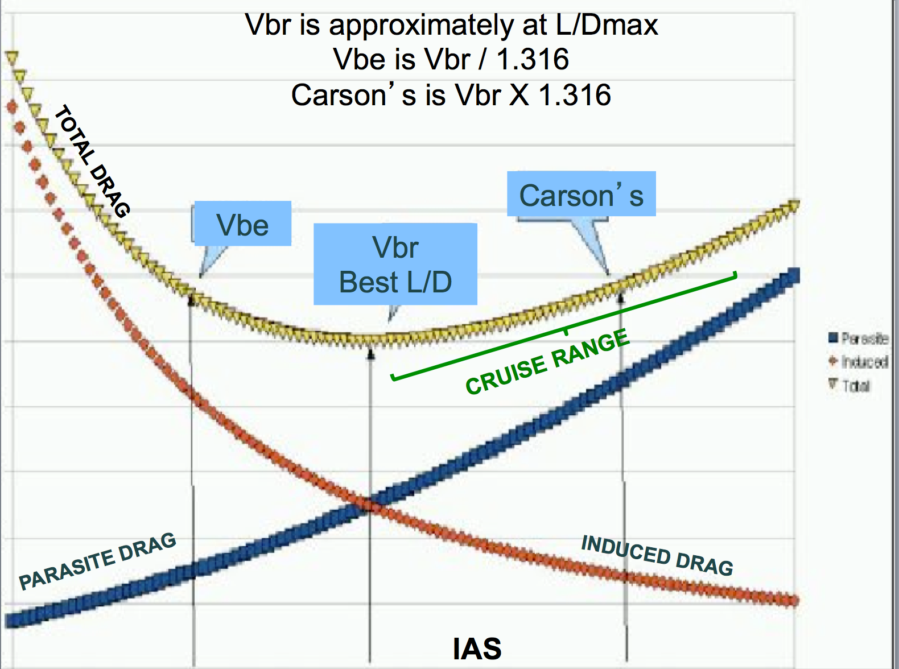

Fig 3. Landmarks of Vbe, Vbr, Vcarson on a graph of induced, parasite,

and total drags. Vbe here referred to as “minimal sink”.

Those three airspeeds relate by the 4th root of 3!

If you ask your calculator for the square root of 3, it will answer with 1.73205. If you ask for the square root of that, the answer will be 1.31607, the fourth root, which rounds to 1.316. The inverse of that number is 0.7598, commonly stated as 0.76 .

So: Vbr X 1.316 = Vldmax Vldmax X 1.316 = Vcarson

or

Vbr/0.76 = Vldmax Vldmax /0.76 = Vcarson

Their Claims to Fame are:

* Flying Vbe, a higher or lower CAS results in less endurance.
* Flying Vldmax, a higher or lower CAS results in best knots/drag.
* Flying Vcarson, a higher or lower CAS results in less knots/drag.

Increasing Vldmax by 1.316, to Carson’s speed, results in a 0.866 reduction (-13.4%) in range performance. drop in Nam/g.

Easy conclusions:

* Vbe is not a strategy for range, but is of value for a holding pattern or other intentional delay.
* CAS above Vcarson may be good for combat, or air racing, but is not a good choice for long range.
* The spread of performance between Vldmax and Vcarson is deserving of consideration.

4. More about Carson Speed

**There’s some likelihood that you’ve seen both of these graphs, unaware, as I was, that they are 2 different graphs; here they are brought together in comparison.**

**The upper graph, Power vs CAS, is I think more common. It is published in Aerodynamics for Naval Aviators. In that graph you see the difference between Maximum Range (Vldmax) and Maximum Endurance (Vbe). Easy.**

**The lower graph substitutes drag for power required on the vertical axis. Drag is a force. How do we convert a force to a power?**

**Power = force times distance/time**

**Rearranging:**

**Force = Power/distance/time**

**At sea level CAS=TAS, so CAS is the distance, distance/hour is velocity (V).**

**Drag (force) = ff/hr (Power)divided by distance/hr = ff/v = fuel flow/v**

**On that lower graph, it is Drag/v, so each point on the curve is FF/V2**

**Force X distance = work. So converting Power to Drag,**

**Force = work/distance**

**So each point on the curve of the upper graph is divided by V and reassigned, making the new curve for the lower graph.**

**The lowest value of P/v2, or ff/v2, or HP/v2, is tangent to the line of**

**Minimal P/v, and that point represents Vcarson , V least ff/knot.**



5. CAS between Vldmax and Vcarson

OK, we want to look at other choices, and need a way to quantify the trade-offs between range and speed. Flying faster or slower then Vldmax gives less Nam/g. That occurred to Byington, and he published this chart.



Fig. 8. Target CAS flown vs Percentage of Max Range Available. Vmr is Vldmax.

The graph predicts that flying:

* 1.00 Vldmax will give 1.0 SR Max miles/gallon (Who knew?)
* 1.07 “ “ 0.99 SR “Long Range Cruise”.
* 1.11 “ “ 0.98 SR
* 1.16 “ “ 0.96 SR My long range favorite, with red circle.
* 1.20 “ “ 0.94 SR
* 1.23 0.92 SR
* 1.26 “ “ 0.90 SR

and finally, there is this special one:

* 1.316 “ “ 0.866 SR = “Carson Speed” (Max knots/fuel flow)

Willing to trade off some range to get more speed, we can increase CAS for a known loss of SR in Nam/g. The bigger the increase in CAS, the bigger is the bite into range performance. When we get up to 1.316 X Vldmax, we are at a new landmark; the airplane is now flying with the highest airspeed/fuel flow. Flying faster, or slower, results in less kts/ff. That airspeed is for any altitude, within engine/propeller capabilities, and is called Carson’s speed.